Jonathan Rile
Partner: Alexander Botten
701085173
CpE 311 – Wednesday 5-7:50
1/29/14

Lab 2: Introduction to DEBUG

Introduction
This lab was about getting to know how to use the assembly and the DEBUG tool on MS-DOS. The lab allows us to use assembly hands on and see what’s actually going on, i.e. see what’s in certain registers.

Exercise 1: Introduction to DEBUG

Experiment
The first exercise starts off by describing how to connect to WVU’s shell so that we could access an emulated version of DOS since our operating system does not offer DEBUG. To do that, we connected through PuTTY and accessed the DOS server through Xming. Once we were connected, we started DEBUG. We then explored each command and figured out what they did.

Results
We successfully connected to the emulated version of DOS and started up DEBUG. We then ran through each command in the table:

Questions
Dump command: “D <address>”
- What is the main purpose of this command?
To display the contents of a specific block of memory.
- What information must be entered to use this command?
An address block, or if left empty it will display CS:100h’s contents.
- What is displayed to the screen when this command is used?
The literal contents of a block of memory.
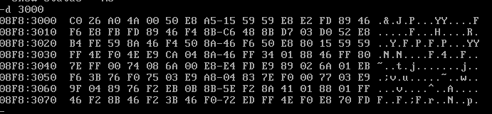
Enter command: “E <address> <data>”
- What is the main purpose of this command?
To enter data into memory.
- What information must be entered to use this command?
The starting location to start entering data, and the data to enter.
- What is displayed to the screen when this command is used?
Nothing is displayed if done correctly. (In the photo below, we used the dump command to verify it worked.)
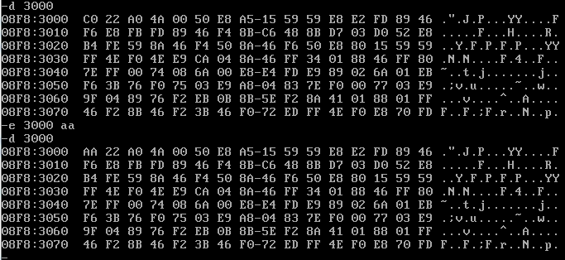
Register command: “R”
- What is the main purpose of this command?
Shows the contents of the CPU registers.
- What information must be entered to use this command?
Nothing.
- What is displayed to the screen when this command is used?
What content is in each of the CPU registers.
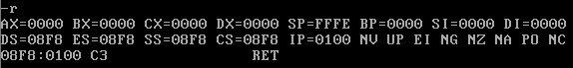
Display single register command: “R <register>”
- What is the main purpose of this command?
To display the contents of a specific CPU register.
- What information must be entered to use this command?
The register’s name.
- What is displayed to the screen when this command is used?
What content is in the specified register.
Execute command: “G <beginning address>”
- What is the main purpose of this command?
To start executing the program being debugged.
- What information must be entered to use this command?
The address to begin executing.
- What is displayed to the screen when this command is used?
Whether the program terminates normally or not.
Proceed to next instruction command: “P”
- What is the main purpose of this command?
Takes a step forward in the program being executed.
- What information must be entered to use this command?
Nothing.
- What is displayed to the screen when this command is used?
The CPU register’s contents or whether or not the program terminated normally.
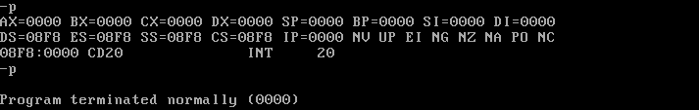
Trace command: “T”
- What is the main purpose of this command?
Seems to function entirely like the proceed command.
- What information must be entered to use this command?
Nothing.
- What is displayed to the screen when this command is used?
The CPU register’s contents or whether or not the program terminated normally.
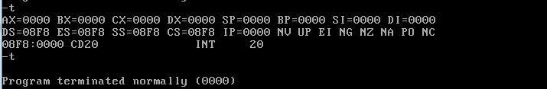
Disassemble command: “U <address>”
- What is the main purpose of this command?
Reads in a block of memory and disassembles it to assembly code.
- What information must be entered to use this command?
The address you would like to disassemble.
- What is displayed to the screen when this command is used?
The assembly code that makes up that block of memory.
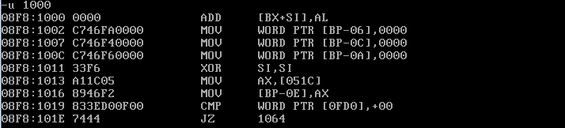

Exercise 2: Using DEBUG

Experiment
For this section, we were to actually run through a series of commands on DEBUG to see what happens. The first thing we did was dump the commands at address 3000. Then we were to insert various types of values into the same address.

Results/Questions
We successfully ran the commands as follows:
- Use the Dump command to view the contents at address 3000 and comment on what is observed.
D 3000 displayed showed the contents of address 3000 exactly as shown in Exercise 1 #3.
- When using the D 3000 command, there are 16 hexadecimal pairs between addresses 3000 and 3010. Explain how this is possible.
Addressing is in hexadecimal so it is possible to store 16 pairs between 10 addresses.

- Use the Enter command to place the value 2B into memory location 3000. Verify the results using the Dump command. What would happen if a decimal value was input rather than a hexadecimal value (e.g. 13₁₀)?
The program expects hexadecimal, so it will treat a decimal value as if it were hexadecimal.
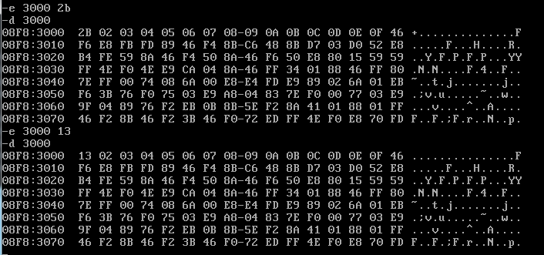
- Use the Enter command to enter the binary number 100011 into location 3000. What operations have to be performed to do this? Comment on the results.
It does not work because it is expecting hexadecimal. It must first be manually converted to insert it.
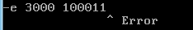
- Use the Enter command to place a list of numbers into consecutive memory locations. Verify the results using the Dump command.
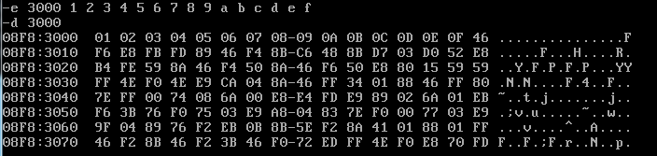
- Use the Enter command to place the letter ‘Y’ into memory location 3000. What bits are actually stored at memory location 3000?
59 is actually stored.
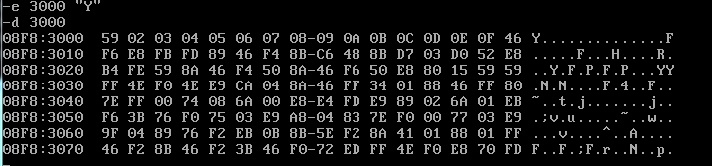
- Using DEBUG, find the hexadecimal equivalents for each ASCII character in the phrase “Who 8 My Apple?!!”
To do this, we simply entered in the phrase and let DEBUG do the work for us.
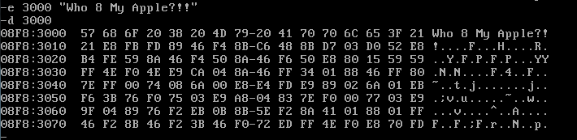
- After an assembly program is written, the assembly instructions are converted into machine code, i.e. instructions that hardware can understand (1’s and 0’s). These 1’s and 0’s are then stored in memory locations, which DEBUG will display in hexadecimal form. The Unassemble command takes the data stored in memory and attempts to convert it back into meaningful assembly instructions Whether this works or not depends on if the data stored is actually part of an assembly program. If the stored data is not part of an assembly program, then the resulting instructions will be meaningless. Try to disassemble the data starting at memory location 2000. Did this do what you expected? Explain the output.
This did do what we expected because it is in a portion of memory where there are actual assembly instructions. If we were to do it on 3000, it would not make sense since that is where we had entered “Who 8 My Apple?!!”
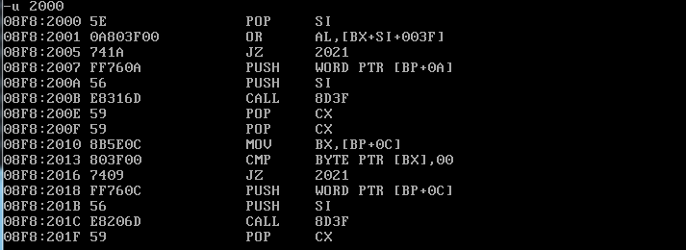

Exercise 3: Number Systems and Arithmetic Review

Experiment
The purpose of this exercise was to do some review on how to convert numbers, which is important to know due to what we have seen with DEBUG only accepting hex.

Results/Questions
Convert the following numbers to hex. (Note, these are in unsigned binary form):
- 0101 0011₂: 53
- 1101 0111₂: D7
Find the Two’s Complement representation of the following:
For both of these, you have to convert to binary first.
- 1500₁₀: 10111011100 → 01000100100
- -1220₁₀: 10011000100 →01100111100
- After running through the entire program, what value is stored in the bx register? Is this the value that was expected? Explain.
0095 is displayed and that is what is expected since that is what E1 + B4 is equal to.
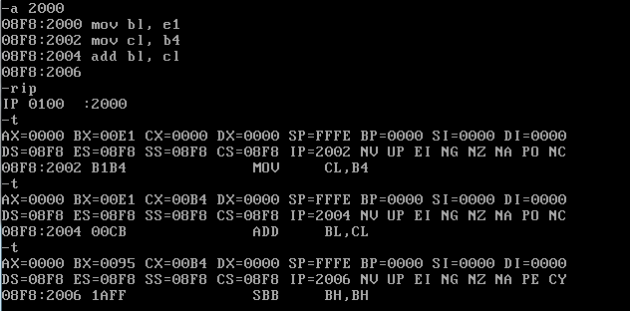
- Repeat the previous question with the values: bl = -2510 and cl = 2010. What is the result in the bx register after the add instruction? What does this process tell you about how negative numbers are handled? Verify your answer by hand.
First we needed to convert from decimal to hex. This made bl = -19 and cl = 14. We received an answer of 00FB, which when converted to binary (1111 1011) and then un-complemented equals 5. This tells us that the programmer needs to know that this number is negative.
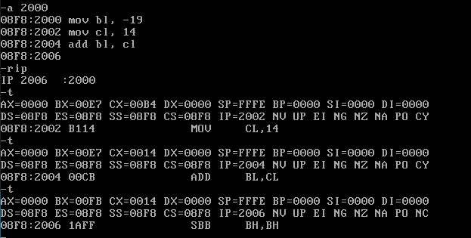

Exercise 4: BCD Encoding

Experiment
This section was to get acquainted with BCD encoding and was not done in the lab.

Results/Questions
- What is packed BCD coding, and what is unpacked BCD encoding?
Packed BCD numbers are stored two digits to a byte in 4 bit groups. Unpacked contains only one decimal per byte. The most signification 4 bits are not relevant, the digit is stored in the least significant bytes.
- What is the number 3150₁₆ in unpacked BCD?
3150₁₆ = 12624₁₀
0000 0001 0000 0010 0000 0110 0000 0010 0000 0100
- What is the number A2B3₁₆ in packed BCD?
A2B3₁₆ = 41651₁₀
0100 0001 0110 0101 0001
- What is the advantage of packed BCD encoding over unpacked BCD encoding?
It is obviously much smaller.

Conclusion
This was a very useful lab that not only got us to review converting numbers, but also gave us good experience using DEBUG. I believe that this will be important especially in this course to know how to do both of these things.

